**CMPS 356 Enterprise Application Development**

**Lab 1 – HTML Basic Tags, Tables & Forms**

**Objective**

Learn and practice how to write:

1. Simple HTML page using HTML5 semantic tags and basic tags such as <h1> to <h6>, <p >, <br>, and <!-- -->
2. HTML Tables: HTML tables allow web authors to arrange data such as text, images, links into rows and columns.
3. HTML Forms: HTML Forms are used to collect some data from the user. For example, during user registration a form can be used to collect user details such as name, email address, phone number etc.

**Overview**

This lab has four parts.

* **In Part A**, you will be required to write a simple HTML page which demonstrates the basic HTML tags.
* **In Part B**, you will design a second page that has an HTML table.
* **In PART C**, you will design a third page that has an HTML form.
* **In PART D**, you will combine the skills you acquired in PARTs A,B and C and create a simple Book Donation Website

After you complete your work you will push it to your cmps356 GitHub repository under the folder named “Lab1-HTML”.

**Preparation**

1. If not done already, visit https://github.com/cmps356s19 or https://github.com/cmps356fs19 and clone your private repository (named YourFirsname-QuUsername-repo).
2. Save the files produced in this Lab under the folder named Lab1-HTML
3. At the end of the Lab push your work to your Github Repository.

**Part A - Basic HTML Tags -Warmup activities**

Explore basic HTML tags using https://www.w3schools.com/html/default.asp

1. Heading [h1 to h6]
2. Paragraph
3. Link and Anchors
4. Quotations and Citations
5. List [type= “I” , “a”, “A”, “i”]
6. Sematic Tags [header , nav , main, section , article , aside , footer]
7. Tables
8. Image
9. Audio
10. Video [ <https://pixabay.com/en/videos/> ] [controls , autoplay]
11. IDs
12. Forms , Input Types [text, date , color …]

**Part B - HTML Table**

1. Create an html file and name it table.html.
2. Design a page that has a single table that looks like the table 1 shown below. Note :
3. Note: Make sure to use the proper border, colspan , rowspan, header on your table design.

Table 1 : HTML table

|  |  |  |  |  |
| --- | --- | --- | --- | --- |
| Book ISPN | Book Name | Authors | | Donator Name |
| First | Second |
| 978-148410-0 |  | John bank | Baba Ali | Ali Mohamed |
| Extra Book | | | | |
| 278-148410-0 |  | Doe wu | Donald Kerry | Abdulahi Hassen |
| 478-148410-0 |  | Tyler Sky | George Bush | Mohamed Ali |
| All books can be claimed from our office in H209 | | | | |

**Part C - HTML Forms**

1. Create a file named forms.html.
2. Design a form that looks like the following form shown below.
3. You should not allow any of the field to be submitted unless they meet the requirement.



**PART D**

**Assessment**

**Due date Sunday 11:59PM**

Create the following simple book donation website. [**A demo will be shown in the lab**]

1. Download all the assets from the class github repo (Ignore this step if you are using blackboard for this lab)
2. Create a project called Lab1-HTML and add the following three html pages
3. index.html
4. book-donation.html
5. thankyou.html

3. Now open the index.html file and add the necessary html content required to produce

the webpage shown below in figure 1.

**Note**: At the top of the page the two underlined text are links that reference the following

pages:

**INDEX.HTML PAGE**

a. Home link should open the index.html file

b. Book Donation link should open the book-donation.html

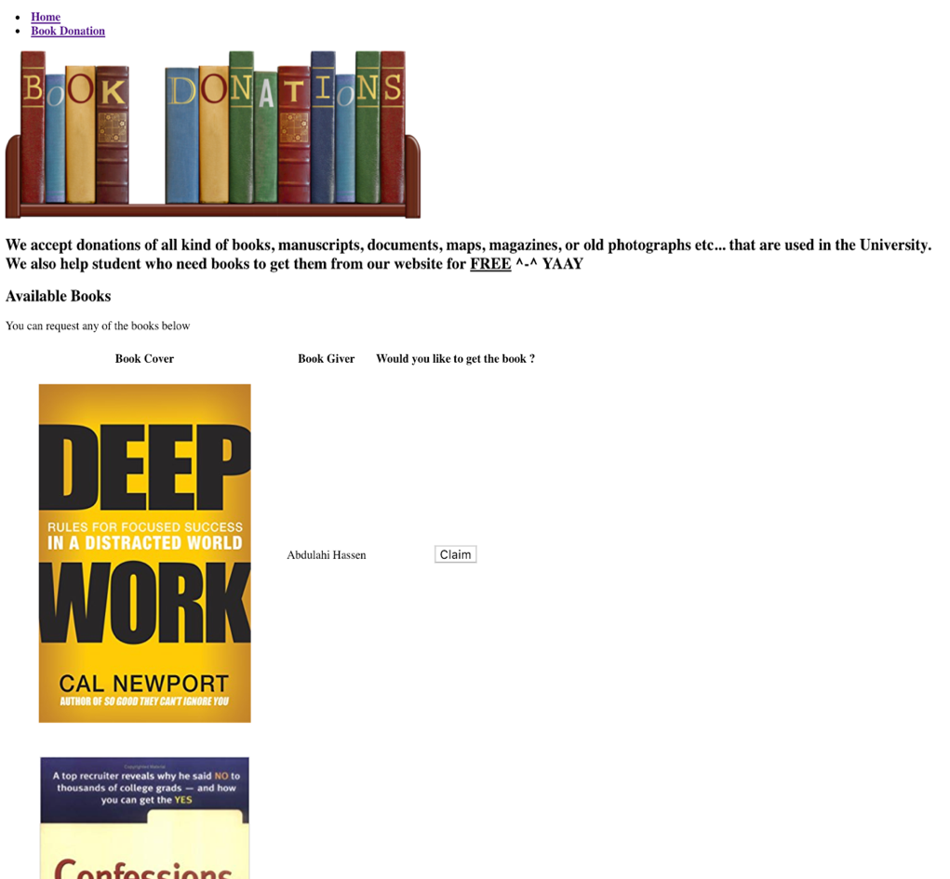

**BOOK_DONATION.HTML PAGE**

1. All the fields must be validated
2. All the form fields should have the appropriate data type

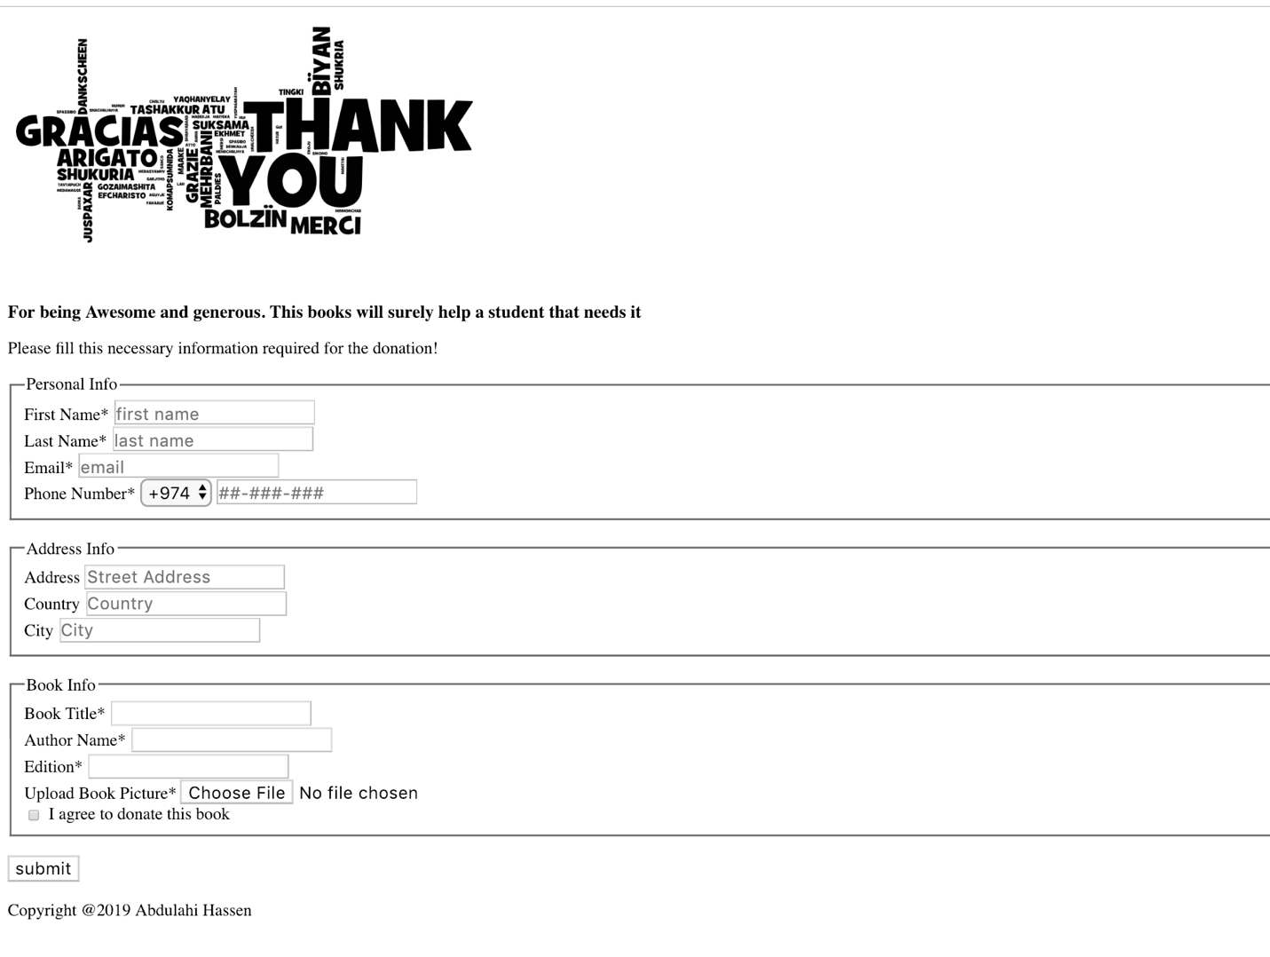**THANKYOU.HTML PAGE**



After you complete the lab:

(1) Fill in the Lab1-TestingDoc-Grading-Sheet.docx and save it in Lab1-HTML folder

(2) Publish your repository to push your work to your Github repo